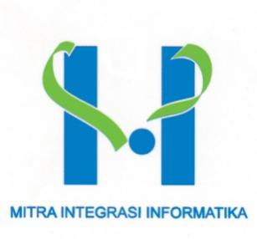

**Kanawa Adi Waskita**

# Personal Data



|  |  |
| --- | --- |
| Date of Birth : | June 27th 1996 |
| Nationality : | Indonesia |
| Marital Status : | Single |
| Gender : | Male |
| Postal Address : | PT Mitra Integrasi Informatika  APL Tower 37th floor, Suite 1-8  Jl. LetJen S. Parman Kav 28, Tanjung Duren Selatan  Grogol Petamburan, Jakarta Barat, 11470 |
| Phone : | +62 21 29 345 777 |
| Email : | recruitment@mii.co.id |
| Foreign Language Proficiency: | English |

# Educational Qualification

**Bachelor of Computer Science at Universitas Dian Nuswantoro,** Majoring in Informatics Engineering Period Period of 2014 – 2020.

# Technical Qualification

Programming Languages:

C# (ASP.NET Core, WEB API), JavaScript, HTML, CSS, jQuery

Database:

SQL, T-SQL, SQL Server

Platform / Operating System:

Windows

Application:

Draw.io

Development Tools:

Visual Studio 2019, Postman, Github Desktop

# Work Assignments

1. **April 2021 – Present, as Junior Application Developer at PT MITRA INTEGRASI INFORMATIKA**

Job description:

* Create Project “Online Examinations” with ASP.NET Core & Web API

Job Specification:

* Back-end Programmer
* Database Designer
* System Analyst
* Quality Assurance
* Front-end Programmer

# Projects

* March 2020, “I Application of Diceware Method For Password Generator Using Diceware Method On PHP”.

# Trainings

* Coding Camp C#, PT. Mitra Integrasi Informatika (April – June 2021)

Technical Training:

* Software Development Life-Cycle Concept
* Object Oriented Analysis Design
* DDL & DML in SQL Server
* C# Programming Language
* C# Framework
* Basic SQL Server Database
* ASP .NET Core, Pattern (MVC, MVVM, N-Layered Architecture), Web API, Web Template (CSS, Bootstrap)
* Basic JavaScript
* Basic Git (Github)
* Implement JWT, BCrypt
* Implement OOP

# Experiences

* Asisten praktikum mata kuliah Struktur Data Non-Linear Program Studi Informatika Universitas Sanata Dharma. (2020)
* Asisten praktikum mata kuliah Pemrograman Berbasis Object Program Studi Informatika Universitas Sanata Dharma. (2019)
* Asisten praktikum mata kuliah SQL Program Studi Informatika Universitas Sanata Dharma. (2019)